**WORKBOOK**

**Bella Needs to Exercise**

Taking Care of Yourself at Home

|  |
| --- |
| **SECTION 1:**  **NEW VOCABULARY** |

Read the words below and say them out loud.

|  |  |  |
| --- | --- | --- |
|  |  |  |
| Bike | Cinema | Football |
|  |  |  |
| Run | Sleep | Strong |

|  |
| --- |
| **SECTION 2:**  **WRITING SENTENCES** |

Copy the sentence provided onto the lines below.

Write a new sentence using one or two of the underlined words onto the lines below.

1. Bella runs to the cinema.  
   \\\\\\\\\\\\\\\\\\\\\\\\

\\\\\\\\\\\\\\\\\\\\\\\\

1. Can I ride my bike?  
   \\\\\\\\\\\\\\\\\\\\\\\\

\\\\\\\\\\\\\\\\\\\\\\\\

1. Let’s play football and stay strong!  
   \\\\\\\\\\\\\\\\\\\\\\\\

\\\\\\\\\\\\\\\\\\\\\\\\

1. Bay wants to sleep.  
   \\\\\\\\\\\\\\\\\\\\\\\\

\\\\\\\\\\\\\\\\\\\\\\\\

|  |
| --- |
| **SECTION 3:**  **COMPREHENSION QUESTIONS** |

Select the correct answer/s for each of the comprehension questions below. Each question has one correct answer, unless stated otherwise.

1. **What did you learn from this story?**

|  |  |
| --- | --- |
| a. | b. |
|  |  |
| Winning is the best. | Football is fun. |
| c. | d. |
|  |  |
| We should exercise every day. | We should run faster. |

1. **Who felt tired after running?**

|  |  |
| --- | --- |
| a. | b. |
|  |  |
| Bay. | Pepe. |
| c. | d. |
|  |  |
| Bella. | Bella’s dad. |

1. **How can Bella become strong and healthy?**

|  |  |
| --- | --- |
| a. | b. |
|  |  |
| Watch videos at home. | Sleep all day. |
| c. | d. |
|  |  |
| Go to the cinema. | Ride a bike at the park. |

1. **Why should Bella ride a bike?**

|  |  |
| --- | --- |
| a. | b. |
|  |  |
| She can go very fast. | She needs to exercise. |
| c. | d. |
|  |  |
| She can race Bay. | She can wear a special helmet. |

1. **Where was Bella playing football?**

|  |  |
| --- | --- |
| a. | b. |
|  |  |
| In the backyard. | At the park. |
| c. | d. |
|  |  |
| At the beach. | In her room. |

1. **What did Bella do last?**

|  |  |
| --- | --- |
| a. | b. |
|  |  |
| Talk to Bay. | Play football. |
| c. | d. |
|  |  |
| Ask Tik Tok for help. | Stop playing football. |

1. **Why did Bella stop playing football?**

|  |  |
| --- | --- |
| a. | b. |
|  |  |
| She hurt her knee. | She felt tired. |
| c. | d. |
|  |  |
| She needed to drink water. | She wanted to ride her bike. |

1. **When might Bella exercise again?**

|  |  |
| --- | --- |
| a. | b. |
|  |  |
| When her mum tells her to. | Tomorrow morning. |
| c. | d. |
|  |  |
| On her birthday. | Tonight. |

|  |
| --- |
| **SECTION 4:**  **KEY MESSAGE** |

We should exercise every day to become strong and healthy.

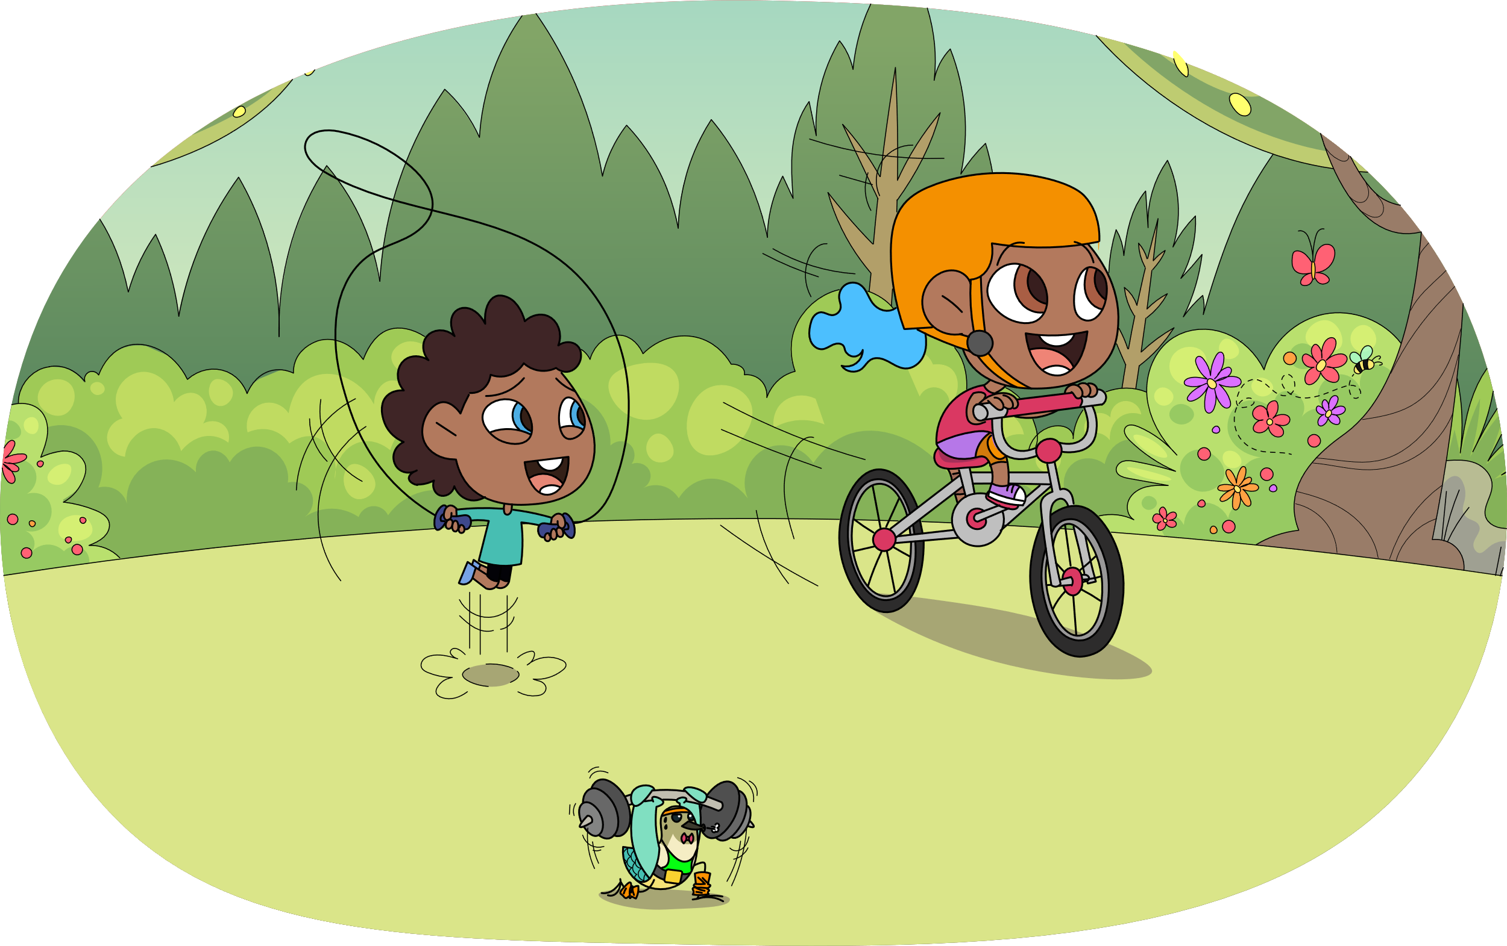

**COMPREHENSION ANSWERS**

**Bella Needs to Exercise**

Taking Care of Yourself at Home

1. **What did you learn from this story?**

|  |
| --- |
| C. We should exercise every day. |

1. **Who felt tired after running?**

|  |
| --- |
| C. Bella. |

1. **How can Bella become strong and healthy?**

|  |
| --- |
| D. Ride a bike at the park. |

1. **Why should Bella ride a bike?**

|  |
| --- |
| B. She needs to exercise. |

1. **Where was Bella playing football?**

|  |
| --- |
| B. At the park. |

1. **What did Bella do last?**

|  |
| --- |
| C. Ask Tik Tok for help. |

1. **Why did Bella stop playing football?**

|  |
| --- |
| B. She felt tired. |

1. **When might Bella exercise again?**

|  |
| --- |
| B. Tomorrow morning. |